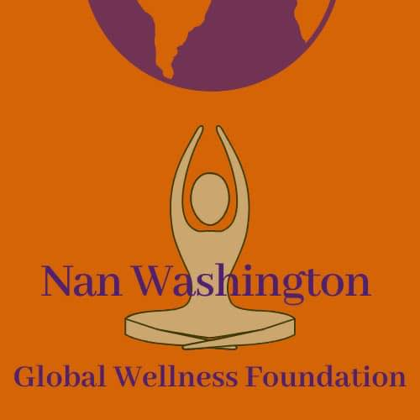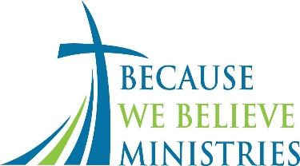
Organizer Community Partner Media Sponsor
Missing Black Woman Disparity Symposium Program
March 23, 2024 10:00AM PST
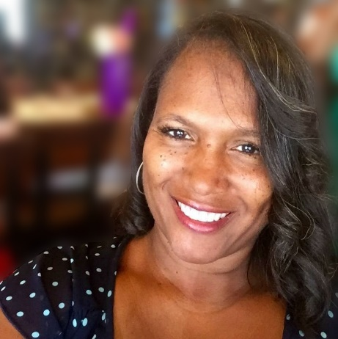
Kasey Phillips Brown, DSW-C, LCSW Founder/Host
Kasey Phillips Brown, DSW-C, M.S.W., LCSW has been providing mental health services for over 30 years. She is the Executive Director of the Nan Washington Global Wellness Foundation and the Missing Black Woman Disparity Symposium and coined the term Missing Black Woman Disparity to describe the lack of awareness in cases of missing Blak women. She earned both her B.A. in Mass Communication and Masters of Social Work from Clark Atlanta University and is currently a Doctor of Social Work Candidate at California Baptist University. Kasey has been certified as a sexual assault crisis volunteer, a Trauma Focused Cognitive Behavioral Therapy clinician and is an Eye Movement Desensitization and Reprocessing (EMDR) Certified Therapist. She has experience as an examination coach and consultant to other licensed clinicians. Kasey is a clinical supervisor providing individual and group clinical supervision to Associate Social Workers and Associate Marriage and Family Therapist at two Department of Mental Health Agencies. Kasey was a part-time lecturer for the School of Social Work at Cal State Long Beach and now runs a private practice, New Perspectives in Gardena CA. She provided mental health services to students and led parent workshops and is on the Sacramento City College Melanated Mental Health Army counseling services team. She is also on the panel for two Employee Assistance Programs for Federal Government employees. Kasey is a certified health coach that assists parents of children who have been diagnosed with ADHD and wrote the highly regarded book "We Just Said No! Treating ADHD Without Medication. She facilitates corporate trainings, business enhancements, college lectures and career consulting.

Opening Sound Bath
Moni Vargas
As a certified yoga teacher, music and sound alchemist, Moni of Ceremoni Sounds crafts experiences that facilitate meditation and self-reflection. With over 20 years of dedicated exploration and learning, she has honed her skills and earned certifications with yoga masters, sound healers, and energy workers from around the world. Moni’s mission is to make these healing modalities accessible to underserved communities, leading groups at community centers for elders, public elementary schools and BIPOC nonprofit organizations.
Moni utilizes the ancient science of yoga, meditation and breath work with the energetic resonance of sound healing, creating an immersive experience that nurtures the body, soothes the mind, and connects to spirit. Whether you're seeking a retreat from the everyday or a deeper connection with your inner self, Moni's sessions are gateways to tranquility and joyous discovery.

Research Panel
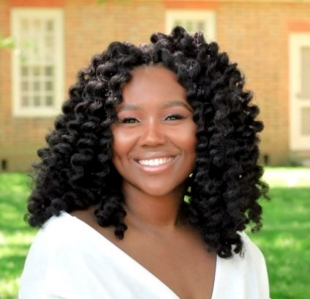
Attorney Jada Moss
Jada Moss is a Washington, D.C. based advocate and attorney, specializing in legislative and regulatory affairs, compliance, and grants management. Jada's Note titled “The Forgotten Victims of Missing White Woman Syndrome: An Examination of Legal Measures That Contribute to the Lack of Search and Recovery of Missing Black Girls and Woman” was published in Volume 25, Issue 3 of the William & Mary Journal of Race, Gender, and Social Justice. Her Note, which has been instrumental in shaping the landscape of missing persons of color advocacy, has been cited in a number of academic publications and on platforms such as CNN. Jada has been called on as an expert on missing persons advocacy, most notably in Audible’s Finding Tamika.
Jada is currently the Assistant General Counsel at The Brookings Institution in Washington, D.C. Previously, Jada served as an Attorney-Advisor at the Department of Housing and Urban Development in the Office of Legislation and Regulations in Washington, D.C., where she practiced legislative, regulatory, and administrative law. She also served as a Global Policy Analyst in VMware’s Global Government Relations office. Jada is a summa cum laude graduate of Virginia Commonwealth University and obtained her Juris Doctor from William & Mary Law School.

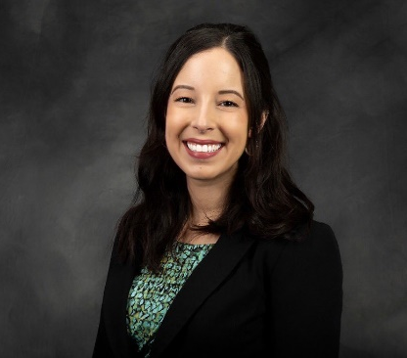

Dr. Danielle Slakoff
An Assistant Professor of Criminal Justice at California State University, Sacramento (CSUS). She is a nationally recognized expert on the media's portrayal of the criminal justice system. She has published extensively on the topic of the Missing White Woman Syndrome and how women and girls of color are differentially portrayed in crime news compared to white women and girls. Dr. Slakoff's research and/or commentary has been featured on several local and national media platforms, including on the nationally syndicated Tamron Hall show, PBS NewsHour, Vice News, The New York Times, The Washington Post, Time Magazine, on the cable news network NewsNation, and on many local television stations and podcasts. In November 2022, Dr. Slakoff received the Saltzman Award for Contributions to Practice from the American Society of Criminology's Division of Feminist Criminology. In 2023, she was a faculty awardee of the Woman of Influence Award at CSUS. Recent Publications: The (Mis)Representation of Queer Lives in True Crime (Routledge, 2023) Slakoff, D.C. (2023). “She did see warning signs but chose to ignore them”: Perpetrator justification and victim-blaming narratives in true crime podcasts about intimate partner violence. Feminist Media Studies. Hyperlink
Slakoff, D.C., Boling, K.S., & Tadros, E. (2022). "I just couldn’t cope with it, you know? I just couldn’t believe that she was gone": The portrayal of co-victims’ grief in true crime podcasts about missing (but presumed killed) women. Journal of Family Violence. Hyperlink

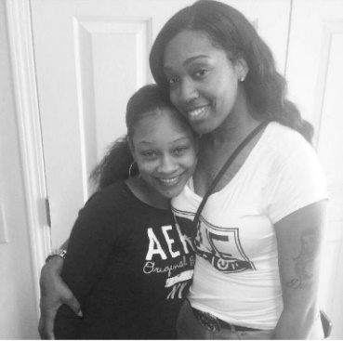
Families of Missing Black Women
Shadira Lee
Shadira advocates for the awareness of missing Black women. Her sister Krystal Anderson was a victim of domestic violence and has been missing since August 20, 2022.
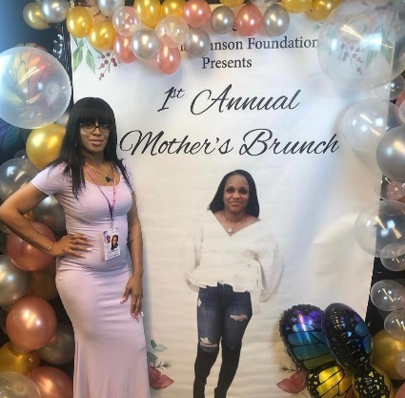
Shalissa Collier- The Mikeona Johnson Foundation
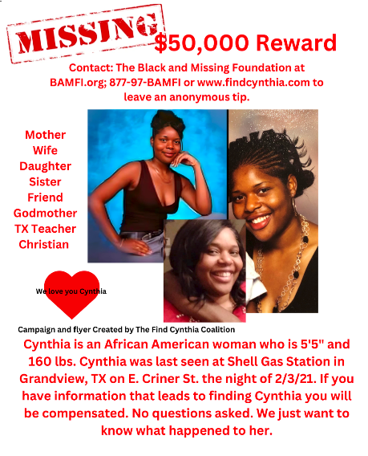
Shalissa is a community member who became an activist after her daughter Mikeona went missing and then died from domestic violence.

Tiffany Alvoid
Tiffany is currently searching for her missing sister Cynthia Bah-Traore who was last seen at a gas station in Grandview, Texas.
Law Enforcement Collaboration Panel
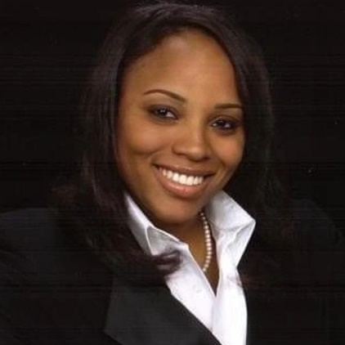

Brit Morris
CEO of mental health nonprofit organization, The Morris-Young Legacy House, Inc., is a multifaceted professional with 16+ years of experience spanning law, philanthropy, and law enforcement management. Noteworthy roles include President of Vintage City Entertainment, LLC, and founding The Morris Legacy Group, LLC, an independent Branding Consultancy.
Brit's expertise extends to mental health and human relations, demonstrated in crafting curricula for California's police academies to improve interactions with those in mental health crises. In law enforcement, her assignments ranged from patrolling diverse neighborhoods to investigating substance abuse cases, elevating her to subject matter expert status.
An ally of the LGBTQ+ community and advocate for African-American communities, Brit's impactful service focuses on mental health and social challenges. Academically, she holds Bachelor’s Degrees in Journalism, Mass Communication, Public Relations, and English; Master’s Degrees in Business Development, Management, and Organizational Leadership; and a Juris Doctorate.
Her nonprofit organization, The Morris-Young Legacy House, Inc. Provides free mental health, mentoring, and empowerment services to Los Angeles County communities and beyond. Her primary mission is to build u underserved communities by helping to prevent mental health crises from occurring.

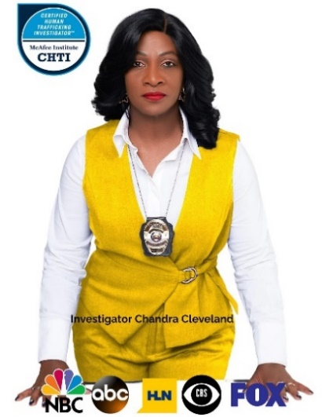
Dr. Chandra Cleveland
Investigator Cleveland is safety expert for women and girls with over 38 plus years of experience in the field of law enforcement. As a veteran law enforcement officer, Dr. Cleveland has worked in a variety of settings, including 22 years with the Richland Sherriff’s Department and, 17 years personal safety, sex trafficking rescuer, finding missing/exploited women and girls, and
self-defense instructor as the owner and president of Columbia Private Investigations and Safety Consultants. Dr. Cleveland has helped rescue hundreds of women and girls worldwide. She is a trainer and speaker nationally and internationally in countries like Afghanistan, Ghana, and India just to name a few on how to respond, recognize and report victims of human/sex trafficking and missing cases in their country.
Dr. Cleveland has been recognized for their contributions to the field with awards such as First Female Officers of The Year for South Carolina, The First Female Internal Affairs, Humanitarian Service Award SC Democratic Party, Community Service Award from South Carolina Black Caucus, Trailblazer Award from the Mayor of Ghana, Trailblazer Award from Sigma Gamma Rho Sorority Inc., Black History Public Servant Award From Richland School District Two, just to name a few. Dr. is certified in Crisis Management, Emergency Response and volunteers and advocacy in her community. She believes that everyone has the right to feel safe and secure and are dedicated to helping people achieve that goal.

Podcast and YouTube True Crime Storyteller Panel
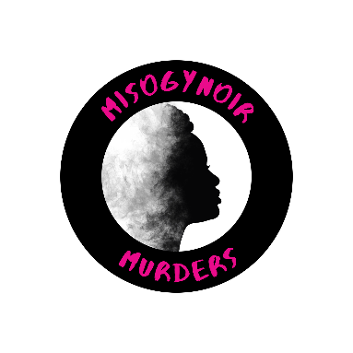
Ronnetta Rideout
Ronnetta Rideout is the founder of Misogynoir Murders Podcast - A true crime podcast dedicated to shining light on the stories of murdered black women and girls. She is currently nominated for three True Crime Awards. “The podcast is produced and hosted by me, Ronnetta Rideout. I’m a true crime junkie at heart but I’m also a mother, wife, daughter, and sister, who couldn’t ignore the fact that the media largely ignores victimized black women and girls. Even in my favorite, true crime podcast, the stories of my kinfolk are in the minority, even though the actual violent crime statistics tell a different story. I figured I would put my interest in true crime, pension for storytelling, and passion for helping my community to good use, and thus massaging while murder was born!”

Blackgirl UNLOST
Blackgirl UNLOST is a YouTube platform that spotlights the injustices of girls and women of color who have tragically lost their lives through senseless violence. Mika Samaya is a DMV native, former accountant and educator of 8 years, working with underprivileged youth in the Southeast area of Washington, DC.

Black Girl Missing (Asa Todd, Feminista Jones, Niki Irene)
Black Girl Missing is a podcast dedicated to telling the stories of Black girls (0-17) who have gone missing in the United States. Some have been found. Some are still missing. Some we have lost forever. Whatever her story, we want to tell it. We explore disappearances from their beginnings, going over timelines of events, looking at the evidence, and recounting witness testimonies. We dig as deep as we can go to uncover the truth about their disappearances.

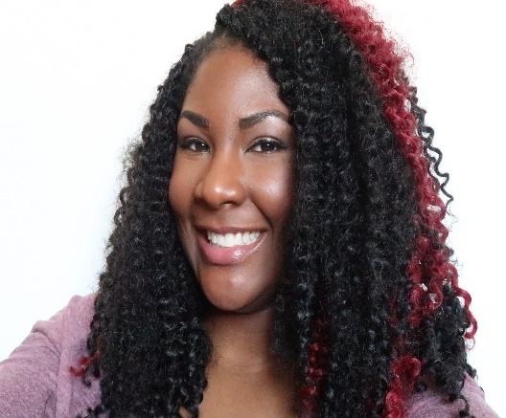
Asa Todd
Asa (she/her) is a New Jersey-based digital media manager and blogger with a passion for all things beauty, as well as a mental health advocate. Living with Bipolar Disorder since the age of 12, Asa wants to ensure that no one else living with a mental illness feels shame or alone in their journey. She decided to incorporate her love for the beauty industry into her writing on her blog, Lithium To Lashes, to show that people living with a mental illness are not as one dimensional as mainstream media portrays them. In her spare time, she is a presenter for the NAMI In Our Own Voices Program.

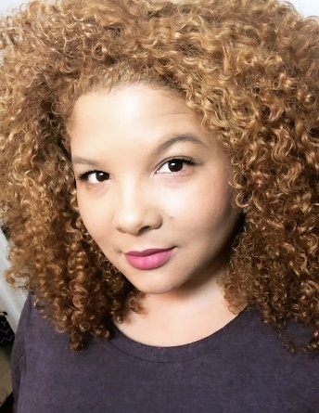

Niki Irene
Niki (she/they) is a Washington, DC-based visual artist, sculptor, illustrator, cultural critic, creative consultant, and advocate for intersectional equality and equity. She frequently advises families and individuals experiencing homelessness on their rights, options, and resources. When she's not volunteering or providing aid she's helping to organize and raise awareness for issues affecting marginalized communities and being the neighborhood Auntie.

Activist Panel
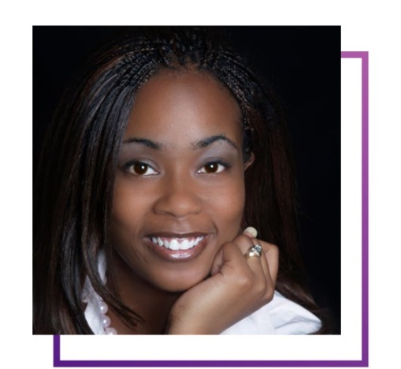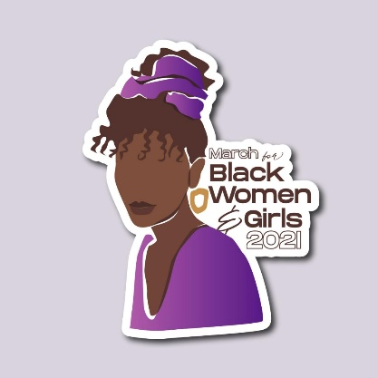
Coffy Davis March for Black women and girls
Author/Poet and speaker Coffy Davis was born and raised in Oakland, California. She has an English and Tech Writing degree from the University of Arkansas at Little Rock. In 2004 Coffy became a trailblazer and created the Underground Railroad Neighborhood project (TURN project) an initiative that bridged art and literacy with at-risk communities. She first became known for her regional stage play, FREEDOM, a play that merged verse and performance.
In 2017 her book MEdusa: Reflections of an Angry Black Girl won the Arkansas State Arts Council Award for Creative Non-Fiction and in 2018 the Nan Snow Emerging New Writer’s Award. She also has written two books of poetry, Ghetto Politics and Reflections in Poetry. In 2019 she became a yoga instructor and fitness expert. She currently speaks at events that center around the empowerment of women and girls, fitness, self-care and writing through trauma.

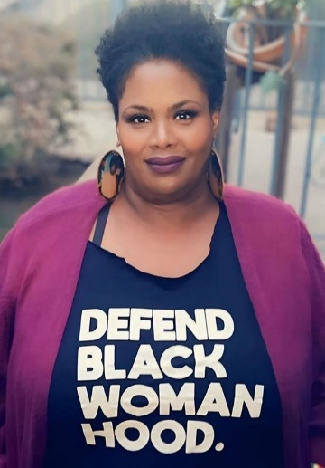

Kathy Evans
Kathy Evans, a dedicated judicial assistant in Los Angeles for over 35 years, is a survivor and advocate for mental health and survivors of sexual assault. She stands with organizations like Cry Heard and REACH for Mental Health to break down barriers in accessing resources. As a SART advocate, she supported survivors on their path to healing and volunteered in the search for missing Black girls (including Mitrice Richardson) and women for 13 years. Kathy's journey is defined by resilience, community, and a commitment to equality and justice.

Legislation Panel
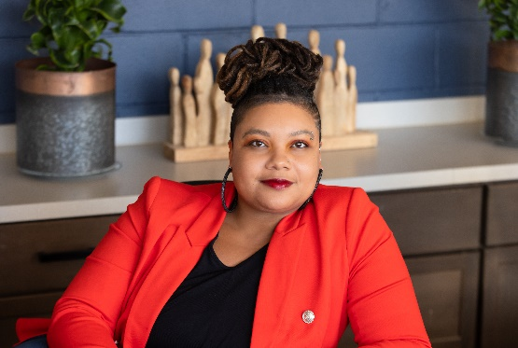
Dr. Brittany Lewis
A former university professor and Minneapolis Federal Reserve Bank Scholar-in-
Residence, Dr. Brittany Lewis has spent over 15 years working in partnership with local distressed communities, helping them to co-create new knowledge and drive policy
change that makes a real, positive difference in people’s lives. Dr. Lewis is the Founder and CEO of Research in Action and a Senior Research Associate at the Center for Urban and Regional Affairs at the University of Minnesota. Dr. Lewis has authored several well-cited policy action reports such as The Illusion of Choice: Evictions and Profit in North Minneapolis, The Diversity of Gentrification: Multiple Forms of Gentrification in Minneapolis and St. Paul, and the Missing and Murdered African American Women Task Force Final Report to the Minnesota Legislature. Her research has been used to catalyze action in many ways, including (1) as evidenced in a Minnesota Supreme Court case to expand rights for tenants facing eviction, (2) informing the Minnesota State Legislature’s human services and public safety impact agenda, (3) removing a harmful self-pay policy at homeless shelters in Hennepin County, (4) guiding the creation of the City of Minneapolis’s tenant protection ordinance, and (4) the creation of the nation’s first Missing and Murdered African American Women's office. Dr. Lewis is featured in the Midwest Emmy award-winning documentary Jim Crow of the North and the radio documentary A Fiery Unrest: Why Plymouth Avenue Burned. She is often interviewed on podcasts and radio, including Feminism NOW and Minnesota Public Radio. Dr. Lewis is the recipient of a 2021 University of Minnesota Community Engaged Scholar Award, 2020 Bush Foundation Fellowship, and the Minneapolis Civil Rights Department 2020 History Makers at Home Award. Dr. Lewis was also named one of the top 100+ Leading Black Women in 2020 by the Minnesota Black Chamber of Commerce. Research in Action is a social benefit corporation founded by Dr. Brittany Lewis, to reclaim the power of research by centering community expertise and driving actionable solutions for social, racial, and economic justice. Research in Action was created to disrupt traditional, top-down approaches and reclaim the power of research by putting community expertise first at every step — from naming the problem to identifying
solutions. Research in Action elevates community members as project leaders at every stage
of its work, from using their expertise to describe the problem to developing the
research processes and tools. It works with institutional or organizational partners
that are committed to an ongoing learning and change process that rejects
traditional transactional relationships with community members and embrace
reciprocal relationships that are accountable to the community.

Cybersecurity Panel
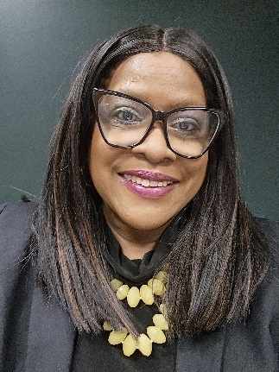
Dr. Sharon L. Burton
Dr. Sharon L. Burton works as a dissertation chair, faculty member, facilitator, author, speaker, and consultant. She has over 100 academic publications to her name and has spoken at over 30 professional conferences. In addition, she has prior experience leading, transforming, driving results, and supporting agile solutions. She is a value generator from problem to solution. Strong collaborator and relationship builder capable of communicating and deciphering technical communication to non-technical audiences and senior leadership while also providing technical resources with business process knowledge. Management of cross-functional, virtual, and on-site teams is required.
Dr. Burton has previously held the positions of Chief Learning & Compliance Officer-Administrator Representative, Board of Trustees; Chief Learning Officer, Senior Project Manager, and Senior Change Management Officer. She has also served on a cyber-security board. She is a mentor and coach, as well as a learner advocate. The following degrees are held: a Ph.D. in Cybersecurity Leadership, a DBA in Quality Systems Management (Business Process Improvement), and two MBA degrees in Human Resources Management and Management. She has a number of certifications. Dr. Burton is available to speak at conferences, forums, and other initiatives.

Community Partner
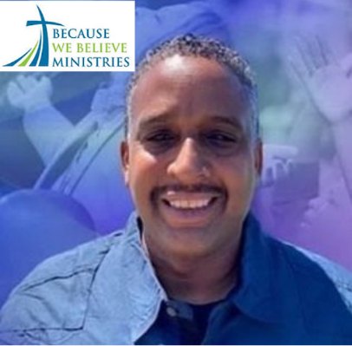
Minister Tyrone Phillips
Pastor Tyrone Phillips was raised in Los Angeles, California and grew up in the South-Central Los Angeles area. He attended Whittier College in the City of Whittier, California where he earned a Bachelors of Arts degree in Business Administration. He has also received a diploma in Discipleship Training from the Church Leadership Training Institute. The Bible says that Jesus is the head of the Church (Colossians 1:18), and it is He Himself who chooses who should enter full-time ministry (Ephesians 4:10-11). Pastor Ty's call to ministry is manifested through the fruit of the Spirit (Galatians 5:22) that are visible to others and he is willing to sacrifice himself to carry out God's will and purpose. ​
Pastor Ty is not only transparent, he's authentic, passionate, and purposeful in his approach to sharing the transforming Gospel of Jesus. He is uniquely created to serve the Body of Believers. Pastor Ty believes that intentional discipleship is the key to developing mature Disciple makers for Christ that are trained and equip to train and equip others. He enjoys spending time with his lovely wife, Lotresa as well as others family members. You can find him tossing a ball around with young people or spending time relaxing by the beach.

